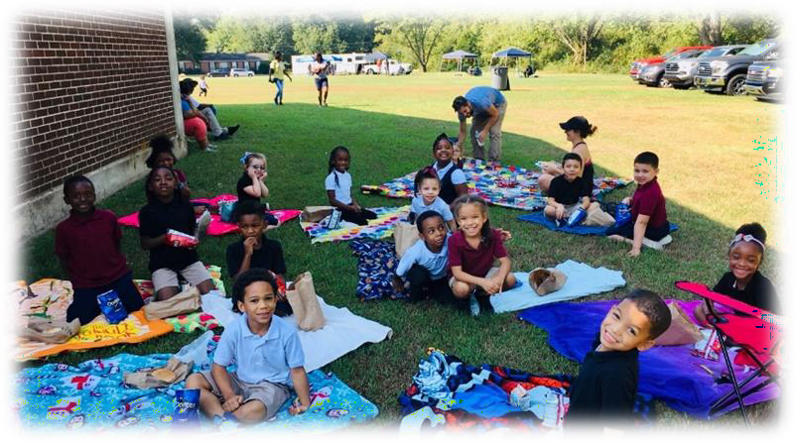

**Andrew Jackson**

**Elementary School**

**2024-2025**

**Parent and Family Engagement Policy for Shared Student Success**

***Plan Revised July 31, 2024***

**School Plan for Shared Student Achievement**

### What is it?

This is a plan that describes how Andrew Jackson Elementary will provide opportunities to improve family engagement to support student learning. Andrew Jackson Elementary values the contributions and involvement of families to establish an equal partnership for the common goal of improving student achievement. This plan describes the different ways that Andrew Jackson will support family engagement and how families can help plan and participate in activities and events to promote student learning at school and at home.

### How is it revised?

Andrew Jackson Elementary School invited all families to attend our annual School open house to review and revise this parent and family engagement policy, the school improvement plan, our school-parent compact, and the family engagement budget.

Additionally, family input and comments regarding this plan are welcome during the school year through an online form. The plan is posted on our school website for families to view and submit feedback throughout the year. All feedback received during the year will be used to revise the plan for the next school year. We also distribute an annual survey online and by mail to ask families for their suggestions on the plan and the use of funds for family engagement. Families can also give feedback during several meetings and activities during the school year.

### Who is it for?

All students participating in the Title I program, and their families are encouraged and invited to fully participate in the opportunities described in this plan. Andrew Jackson will provide full opportunities for the participation of parents and family members with limited English, with disabilities, and of migratory children.

**1A**

### Where is it available?

At the beginning of the year, the plan is included in the student handbook and sent home with all students. As a reminder, we will email the plan to all families in August. The plan will also be posted on the school website and social media. Families can also retrieve a copy of the plan in the front office of the school.

### What is Title I?

Andrew Jackson Elementary School is identified as a Title I school and part of the Every Student Succeeds Act (ESSA). Title I is designed to support state and local school reform efforts tied to the challenging state academic standards to improve teaching and learning for students. Title I programs must be based on effective means of improving student achievement and include strategies to support family engagement. All Title I schools must jointly develop with parents and family members a written parent and family engagement policy.

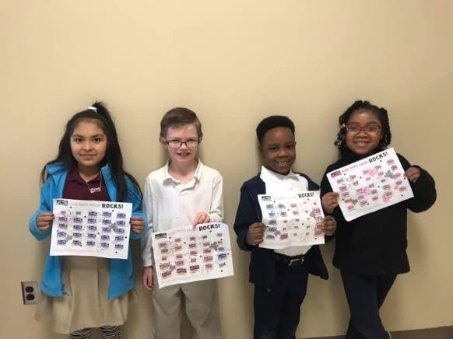

**When students, schools, families, and communities come together – we can achieve our goals!**

### Andrew Jackson Elementary School

Ryan Kirkbride, Principal

Old Hickory

Jackson, TN 38305

(731) 668-8023

[www.jmcss.org](http://www.jmcss.org/)/andrewjackson

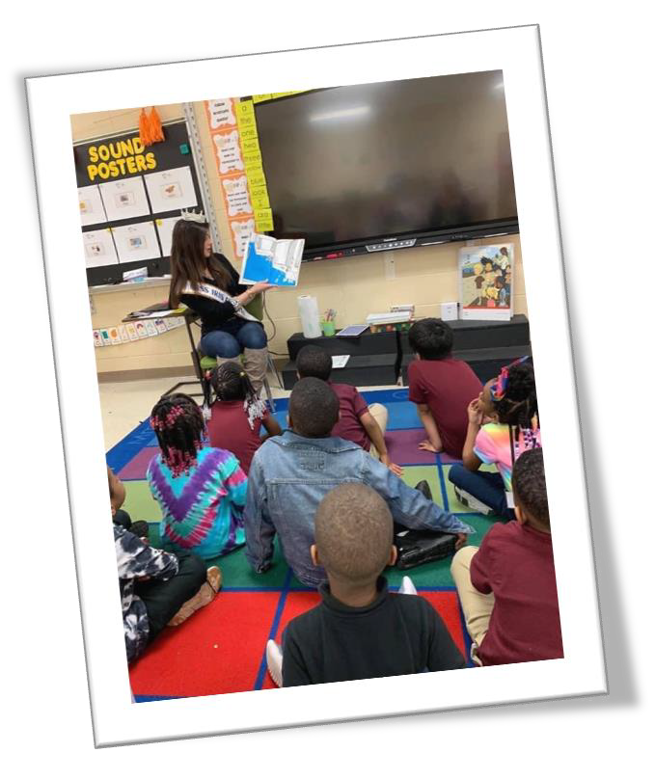

**2024-2025 District Goals**

Career Readiness

* Academic Acheivement and Growth
* Teacher Recruitment and Retention
* College and Career Readiness
* Improve our Systems of Support

**2024-2025 Andrew Jackson Elementary**

School Goals

* + Increase Reading and Math levels for every student.
  + Ensure that all students have at least one year’s growth
  + Provide a rigorous curriculum that will allow our students to become critical thinkers.
  + Provide each child with a quality education that will help to develop his/her talents so that each student reaches their full potential.

## Parent and Family Engagement

Family Engagement means the participation of parents and family member in regular, two-way, and meaningful communication involving student academic learning and other school activities, including ensuring:

* Families play an integral role in assisting their child’s learning
* Families are encouraged to be actively involved in their child’s education at school; and
* Families are full partners in their child’s education and are included, as appropriate, in decision-making and on advisory committees to assist in the education of their child.
* The carrying out of other activities, such as those described in Section 1116 of the ESSA.

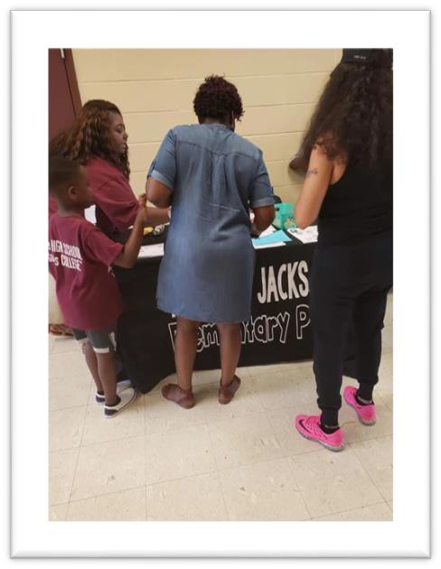

**School-Parent Compacts**

As part of this plan, Andrew Elementary and our families will develop a school-parent compact. A compact is a written agreement that families, teachers, and students jointly develop to explain how everyone will work together to ensure all students reach grade-level standards. The compacts will be reviewed and updated annually based on feedback from families, students, and teachers during various events and the annual School Forum. The school-parent compacts are also displayed in each classroom, shared with families during parent-teacher conferences, posted on our school website ([www.jmcss.org](http://www.jmcss.org/)). Extra copies are always available in the front office. If you would like to provide feedback on the compact any time during the year, please contact Ryan Kirkbride @ (731)506-2205 or @ [rmkirkbride@jmcss.org](mailto:rmkirkbride@jmcss.org).

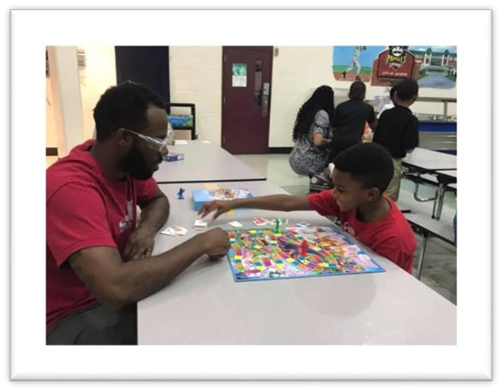

### Parent Brochures

Parent Brochures are located in the front office. These brochures are related to various topics and are created to encourage parental involvement in the education of your child.



Andrew Jackson is committed to helping parents

and families. Please contact Ms. Moira Chandler, Professional School Counselor, at 731-506-2920 for more information regarding family resources and assistance.

# **Andrew Jackson Elementary is**

**branching out!**

Andrew Jackson will take the following measures to empower and support families as an important foundation of our school in order to strengthen the school and reach our goals.

We will:

Make an effort to publish all school information about programs, meetings, and other school related activities in English and Spanish.

* Provide monthly trainings for staff during their planning periods on strategies to improve communication with families and ideas to increase family engagement in reading and math for our students outside of the classroom. Staff will also share promising practices in family engagement during regularly scheduled faculty meetings.
* Partner with early childhood programs, middle and high schools, college-and career-ready resources or organizations, parent resource centers, or other programs (as applicable) to help prepare parents and their children for successful school transitioning.
* Share information in English and Spanish on the school blog and in the school newsletter for families to understand the school’s academic standards and

assessments as well as the ways families can monitor their child’s progress and work

with educators.

* Communicate with all families and the community on a regular basis regarding schoolwide events and activities, through phone messages, school website, social media our parents and family members attend the media, and flyers.
* Work with our families to develop relevant trainings and helpful presentations to educate our staff on the importance of parent and family engagement and how to support student learning.
* Provide necessary materials and handouts for parents at conferences, meetings, and activities to help parents work with their child to improve their child’s achievement.
* Use our Partners in Education and School Community Team to improve awareness of the activities and events listed in the school parent and family engagement policy.
* Collect feedback from parents and family members at all events, place input cards around the building and post a suggestion form on the school website in order to respond to parents’ requests for additional support for parent and family engagement activities.

# Let’s get together!

Andrew Jackson will host the following events to build the capacity for strong family engagement and support a partnership among the school, families, and the community to improve student academic achievement. See the entire listing of events on our website: [www.jmcss.org.](http://www.jmcss.org./)

#### Annual Title I Meeting – August 2023

We invite you to an evening of learning and sharing about our Title I program, including our parent and family engagement policy, the schoolwide plan, and the school-parent compact. Invitations will be emailed and posted on school website/ social media.

#### Title I Family Meeting/ESL Open House – August 2024

Title I Overview & Meet your child’s teacher and learn about important grade level skills and standards that your child will be working on this year

#### Fall Festival– October 2024

Parents, students, and all key stakeholders are engaged with fun activities and an opportunity to communicate outside the classroom.

#### School-Wide Picnic– October 2024

The all-school picnic is an opportunity for community and relationship building for parents, students, teachers, and community partners as the new school year begins.

#### Literacy Night/Book Fair– October 2024

Learn helpful information about reading activities and the reading curriculum used during the school year.

Parents, students, and all key stakeholders are engaged with fun activities and an opportunity to communicate outside the classroom.

#### Winter Program- December 2024

Families can enjoy a delightful lunch with the kids during this Christmas season. Also, the students will perform a seasonal play.

#### Math/Stem Night- January 2024

Students and parents participate in math related activities and learn more about our math common core standards.

#### Black History Program- February 2025

A celebration to honor the heroes of Black History Month

#### TN Ready- April/May 2025

Students in grade second through fifth will take TN-Ready test.

#### Fifth Grade Graduation - May 2025

The fifth-grade students will celebrate their transition to middle school with a graduation.

#### EOY Awards Day – May 2025

Students in grades first through fourth will be honored for their academic achievement.

#### Kindergarten Graduation- May 2025

Kindergarten students transition to first grade with a graduation ceremony.

Parent and Family Engagement Standards

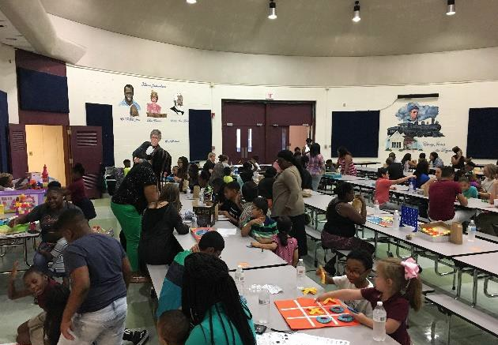Andrew Jackson Elementary and our families have adopted the National PTA Standards for Family-School Partnerships as the school’s model in engaging parents, students, and the community. These standards are:

Welcoming All Families Communicating Effectively Supporting Student Success Speaking Up for Every Child Sharing Power



Collaborating with Community

## School Community Team

Andrew Jackson Elementary invites all families to join the School Community Team to share ideas and ways to involve others to build partnerships with school, families, and the community. The team will meet four times during the school year, but parents and

family members can also submit their ideas or suggestions at any school activities and meetings, as well as through our family surveys and website. If you would like to learn more about the School Community Team, please contact (731) 668-8023 or complete the interest form below and leave it in the front office.

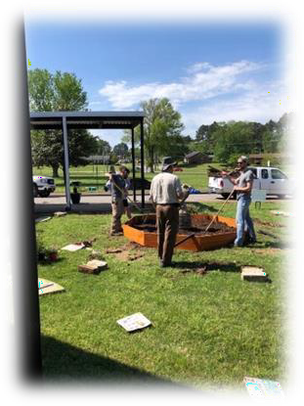

## School Community Team



Yes, I am interested and wish to join the School Community Team.

Please contact me so I can learn more about joining the School Community Team. Please send me notifications about future meetings and updates.

Name:

Child’s Name and Grade Level:

Address:

Phone Number:

Email Address:

## Share Your Thoughts

We want to hear from you! If you have any suggestions or if there is any part of this policy that you feel is not satisfactory with the students’ and the school’s goals for academic achievement, please provide us with your comments in the space provided and leave this form in the front office:

Name (optional): Phone Number (optional):

Comments: